


PrimeTime Activity Center
Lutheran Service Society

Hours: Monday–Friday | 8:00 a.m.–2:00 p.m.
Phone: (412) 307-1782

Notice: The center will be closed Thursday, January 1.

At PrimeTime, we are committed to providing a welcoming, engaging, and safe environment for everyone who walks through our doors. As we move through the winter season, we appreciate your partnership in keeping our community healthy and informed.

Health & Weather Updates
Cold and flu season is upon us. Please stay home if you are not feeling well. For the well-being of all participants, anyone who appears unwell may be asked to return home. In the event of severe weather, center closures will be announced on KDKA-TV and will scroll as Lutheran Service Society PrimeTime Activity Center. We also update our voicemail as early as possible with the latest information.

January Highlights & Important Information
- Tech Tutoring with Angie – Thursdays
Personalized technology support to help you navigate smartphones, tablets, and everyday digital tools with confidence.
- Art Club with Bayne Library – January 6
A relaxed, creative session featuring guided art activities and calming coloring, hosted in partnership with Bayne Library.
- Pet Therapy with Hadley – January 7 & 21
Spend time with Hadley and enjoy the comfort, connection, and stress-relief that animal-assisted therapy brings.
- Elvis Presley’s 91st Birthday Celebration – January 8
Celebrate the King of Rock & Roll with music, trivia, fun facts, and a sampling of Elvis’ favorite snack—classic peanut butter and banana sandwiches.
- Heart Health Presentation & Blood Pressure Screenings – January 13
Confiable Health will share practical heart health information and offer on-site blood pressure screenings.
- Crafting with Pat – January 16
Join Pat for one of her creative and engaging craft projects. Sign-up required; space is limited to 10 participants.
- Stretching Your Grocery Dollars – January 20
Kato Sherman from Humana will provide helpful strategies for managing grocery costs while maintaining nutritious choices.
- Movie Day – January 21
Pull up a chair, relax, and enjoy a featured film in good company.
- Health Care Directives Explained – January 22
Betsy Swauger from Bethany Hospice will discuss health care directives, what they are, and why they matter.
- Table Talk: “All About Me” – January 23
April Merriman leads a guided conversation focused on personal stories, reflection, and meaningful discussion.
- Bingo Bash at Provence Assisted Living – January 27
Join us off-site for a morning of coffee, pastries, bingo, and lunch hosted by our friends at Provence Assisted Living.
Sign-up required.
- Cooking Club – January 29
Warm, comforting recipes and shared conversation with good food.

Lunch- You must pre-register using Copilot. Meals MUST be ordered 2 days ahead of time. A waiting list will be available the day of. All meal recommended donations are $3. Lunch is served at 11:30AM. If you are not here by 11:40AM, your lunch is released to the waiting list.
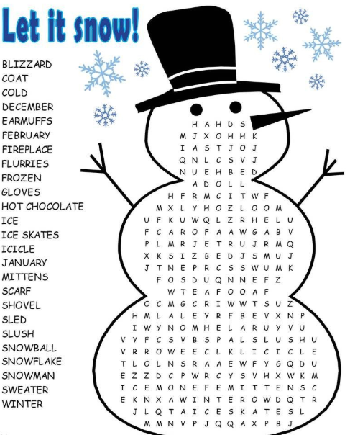
Fitness
Exercise Classes- With Pat Pacey
Mondays 10:15AM
Tuesdays & Thursdays
12:30PM
Recommended donation of $1
Waivers MUST be completed before attending.
Equipment is available in our Fitness Center
.

Group Trips

January 7th - Wednesday
Cheesecake Factory

January 14th - Wednesday
Robinson Mall

January 28th - Wednesday
Rivers Casino
You must have ACCESS in order participate in-group trips or you can drive yourself. The times are subject to change due to ACCESS availability.

PrimeTime Bingo
Every Monday & Friday from 12:15PM– 1:45PM we host Bingo! Regular games cost 25 cents each. You receive 3 cards per game, there are typically 9 regular games. You can buy up to 3 additional cards for 10 cents each OR, you can buy 3 additional cards for 25 cents. The maximum number of cards is 6 cards. Regular games win by vertical, horizontal, diagonal, 4-corners and big diamond.
Specials cost 25 cents a piece, with a limit of 6 cards. There are 3 special games, specials win by inside round robin, double postage stamps, letters X & T up or down.
Secret Number ticket for the day is 25 cents, and only applies to the Regular games. If you win bingo on the secret number that day, you win the secret number jar which has all the money that has accumulated from the secret number payments.
The Last game is a cover all “JACKPOT” which costs 25 cents per card with a limit of 6 cards.
We usually have around 12-15 players and payouts depend on how many players. Specials usually pay out about $5-$6 per game and regular games are less.
*Please note that once a new game begins, you cannot call Bingo on previously played game. Bingo cards not in use are to be removed from all tables and chairs during games. All bingo cards are LSS property and must stay at the center.
Bible Study
Gordon Strunk is a retired Lutheran Pastor. He has a Masters of Divinity. Gordon was an ordained pastor for the Association of Free Lutheran Congregations at St. John’s Lutheran Church in Ambridge for over 12 years. He has traveled to the Holy Land 4 times. Gordon has an ecumenical focus, so everyone is welcome! The class is currently studying the
Book of Acts.

All are welcome to attend and join Gordon on Monday mornings at 9:00AM! For questions, feel free to reach out to Gordon at
412-720-5396.
.


JANUARY 2026
PrimeTime  Activity  440 Lincoln Ave  Pittsburgh  (412) 307-1782  Monday-Friday  8AM-2PM | MONDAY | TUESDAY | WEDNESDAY  Jeopardy w/ Bridget 10AM  MOVIE-It Happened on 5th Ave, Noon  Group Trip  Casino  *must be signed up for ACCESS | THURSDAY | FRIDAY
 | 29  Bible Study 9AM  Chair Aerobics- 10:15AM  Bingo– 12:15PM | 30  CORE Health & Wellness BINGO 10AM  Exercise Class: Pat  12:30PM | 31 | 1  Elvis Day: Trivia Snacks, Songs 10:00AM  Tech Tutoring- 11:30AM  Exercise Class: Pat  12:30PM  Center Closed    Brain Boost- 9:30AM  Tech Tutoring-  11:30AM  Dance & Be Fit-  12:30PM | 2  Wii-Sports 10AM  Bingo– 12:15PM
Information & Referral  Assistance & OPT Info  412-307-1778  10AM– 2PM | 5  Bible Study 9AM  Chair Aerobics- 10:15AM  Bingo– 12:15PM | 6  Bayne Library 10AM  Exercise Class: Pat  12:30PM | 7  Pet Therapy - 10AM  Group Trip  Cheesecake Factory  *must be signed up for ACCESS | 8  Wii-Sports 10AM  Tech Tutoring- 11:30AM  Exercise Class: Pat  12:30PM | 9  Wii-Sports 10AM  Bingo– 12:15PM
Lunch is served at 11:30AM  Provided by the  Area Agency on  Aging Department of Human Services. Please sign up 2 days ahead of time.  Suggested  donation of $3 | 12  Bible Study 9AM  Chair Aerobics- 10:15AM  Bingo– 12:15PM | 13  Confiable Health Blood pressure screens & Heart Health -10AM  Exercise Class: Pat  12:30PM | 14  Group Trip  Robinson Mall  *must be signed up for ACCESS | 15  Bethany Hospice, “Health Care Directives” -10AM  Tech Tutoring- 11:30AM  Exercise Class: Pat  12:30PM | 16  Pat’s Craft 9:30AM  Bingo– 12:15PM
 | 19  Bible Study 9AM  Chair Aerobics- 10:15AM  Bingo– 12:15PM | 20  Humana, “Stretching Your Grocery Dollars” -10AM  Exercise Class: Pat  12:30PM | 21  Pet Therapy - 10AM  Movie: Love Actually, 12 Noon | 22 | 23  Table Talk w/ April 9:30AM  Bingo– 12:15PM
Fitness center equipment available for use! | 26  Bible Study 9AM  Chair Aerobics- 10:15AM  Bingo– 12:15PM  BINGO Bash at Provence Assisted Living, 10:30AM  Exercise Class: Pat  12:30PM | 27 | 28  Group Trip  CASINO  *must be signed up for ACCESS | 29  Cooking Club 10AM  Tech Tutoring- 11:30AM  Exercise Class: Pat  12:30PM | 30  Wii-Sports 10AM  Bingo– 12:15PM

